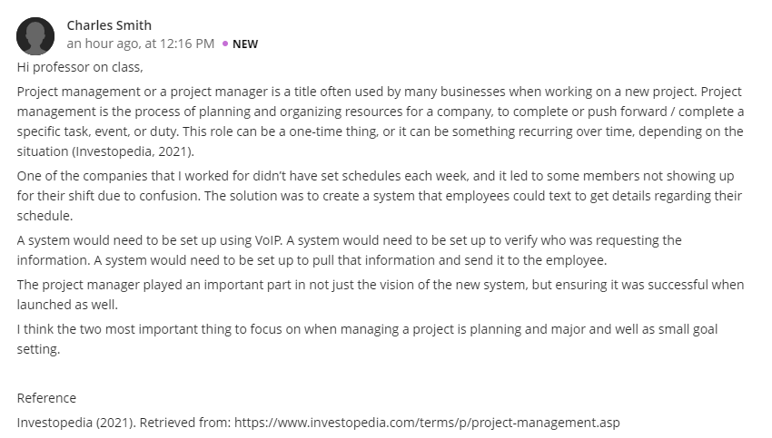
Reply 1
Hi! Smith
That was agreat move on the part of the company you work in, setting up asystem meant the company is likely to benefit from it both in the short and long-run.Consequently, I believe time management issue will automatically be eradicated due to the fact that, all employee within the organization will be in aposition to use the VOIP system to program themselve and be sure that they are available to execute tasks alocated to them at aspecific time.
Furthermore, I gree with you on the significance of aproject manager at large,Most of them as act the main engine of the project and without them giving out well though directives,most projects tend to either delay to be completed or at worse fail to be achieved.We therefore appreciate the role of the project manager not only as just the vision of the new system but in ensuring that the prject becomes successful when its lauched.

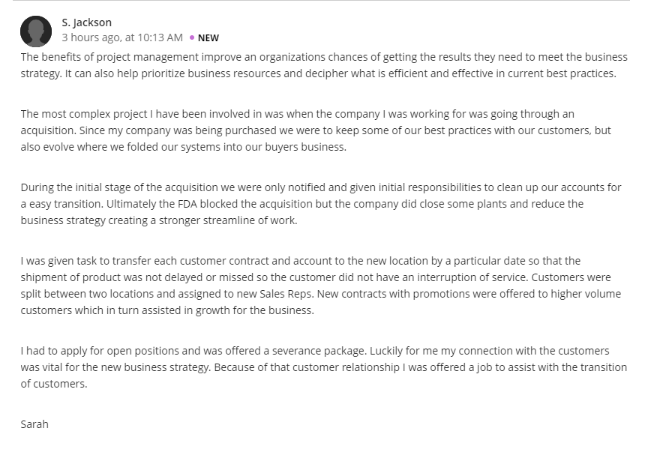Reply 2
Hello Jackson,
It must have been the most technical part of it for you to have successfully achieved a lot in a new business setup. Customers play an important role in pushing the business to achieve its set profit margin and to achieve that, it has to start by creating a reasonably good connections with them, because powerful customer relationships are essential to business success. But, they aren’t built overnight. Just like personal relationships, it’s important to cultivate and nurture customer relationships.
When employees in an organizations develop strong relationships with their customers, it can lead to loyal clients, positive word of mouth and increased sales. On the other hand, while meaningful relationships require time and effort to build, they can fall apart quickly. Relationships taken for granted deteriorate in a flash. I believe this could be the skill that you have mastered and you are absolutely good at. That was a great move!

